Lesson 12 Lab: Observational Research
Lab Objectives
- Conduct an observational study
- Think about the positives and negatives of this study
Observational Study Background Information
Hypothesis:
Pedestrians who are talking on their cell phones or using an MP3 (or similar headphone device) will be more likely than people not using these devices to endanger themselves by stepping into traffic

The Set Up
You will need to find an intersection that doesn’t have stop lights and/or pedestrian crossing signals. The reason for this is that these things provide cues to the pedestrian about when it is safe to cross the street, and we are really interested in how the pedestrians’ behaviors (looking before crossing) are impacted by potentially distracting devices. You will be making six sets of observations for 5 minutes at each observation station.
This is a map of an “X intersection”.
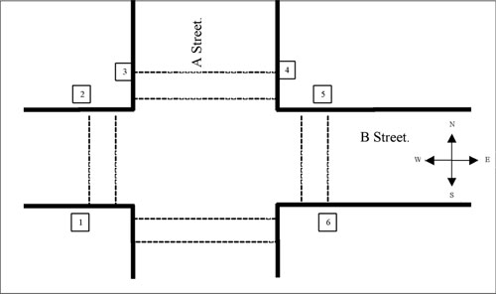
The boxes with numbers represent observation stations. At each station you will observe individuals that are heading toward the station as they cross the street. In other words, Station 1 observers will be standing on the South side of B Street looking toward the North side of B Street. You will record the behavior of individuals who are coming toward your side of the street. Station 2 observations, on the other hand, will be observing individuals who are on the South side of B Street, but who are crossing to the North.
This is a map of a “T intersection”.
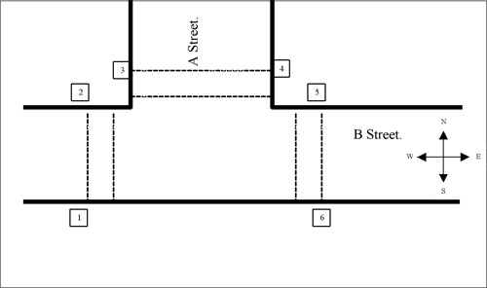
You can use either kind of intersection. You will notice that the X intersection only has 6 observation posts, when it could really have 8. I only need you to make observations from 6 stations, so if you choose an “X intersection” you can skip one of the street crossings. If you choose a “T intersection” then you will make observations from the 6 observation posts.
Important!
Your safety and the safety of others is more important than this assignment, therefore if you cannot conduct this study in a safe environment, or if you live in an area where there is not enough pedestrian traffic, you are welcome to use an internet source to conduct your study. There are several websites that have cameras pointed around (www.earthcam.com is one example). Try to follow the procedure even if you are working from an online resource. Additionally, if there are other aspects of this assignment that might make it unreasonably difficult, please contact me right away. We can figure out some options for you to get the experience of conducting an observational study in some other way.
Coding Sheet
On your Coding Sheet (click to download a copy), you will record the gender of the participant, whether they are talking on a cell phone or MP3, and how many times they looked for traffic before stepping into the street. (NOTE: Use the MP3 box if the participants are using any sort of headphones)
Your coding Sheet looks like this.
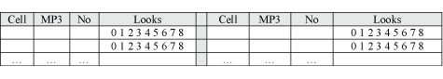
The first set of columns is where you will indicate if the individual is talking on their cell phone, using an MP3 (or similar device), or using nothing.
You will also use this space to record the person’s gender.
- If they are a male speaking on the cell phone then you would write “M” in the Cell column.
- If it is a female who is NOT speaking on the cell phone then you would put “F” in the No column, and so on.
In this way you will simultaneously record both the person’s gender, and whether or not they are talking on a cell phone or using an MP3.
Finally, you will observe the number of times that you see them look to the right or left to check for traffic.
- You will count from the time that they are a few feet away, up until the moment that their foot touches the street.
- Once their foot has touched the street you will stop counting (even if they look while in the street).
- The number of “looks” will be counted as the number of times that an individual moves their head to the right or left.

- For example, if a person approaches the street looking straight ahead, then looks right, then left, then right again before stepping into the street you would count that as 3 “looks”.
- The length of time that the person looks right or left doesn’t matter. We are only interested in the number. When you have a count you will circle that number on your sheet.
The sheet should then end up looking like…
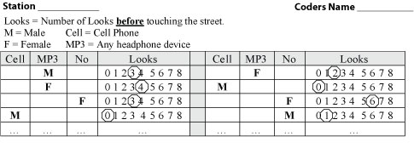
There are two sets of columns on each sheet (separated by the gray column in the middle of the page). This was done to save space. Use both columns to record as many observations as you can.
Note: You will need to label each sheet at the top. Indicate which station you are working at. I don’t care about getting things oriented in terms of North and South, just start with one corner, then move to the next and the next, around the intersection. Each station’s observations should be on a new sheet, so you will need to print 6 copies of the coding sheet.

Things to Keep in Mind
When you get to the location that you’ve chosen take a look at what you have to do.
- Before you begin figure out the best strategy for collecting the data.
- Take a few minutes to observe what is going on without trying to record anything.
- Practice what you will need to do. Once you have a plan, begin data collection.

- You will collect data for 5 minutes at each station. Be sure to only count the data that happens within the five minute period at that station.
This ain’t gonna be easy. You may encounter a situation where 10 people all approach the crosswalk at the exact same time, and it will be impossible to count everyone.

Do the best that you can. After you have collected the data you will be asked to discuss the problems for the Lab Assignment.
Important!
Your safety and the safety of others is more important than this assignment, therefor if you cannot conduct this study in a safe environment, or if you live in an area where there is not enough pedestrian traffic, you are welcome to use an internet source to conduct your study. There are several web sites that have cameras pointed around (www.earthcam.com is one example). Try to follow the procedure even if you are working from an online resource. Additionally, if there are other aspects of this assignment that might make it unreasonably difficult, please contact me right away. We can figure out some options for you to get the experience of conducting an observational study, in some other way.

After the Data Collection
You will need to enter the data into a spreadsheet. In the “Lab” folder there is an excel file called Lab 12 Observation Study.
- Download this spreadsheet and enter the data (there is a coding key for the data on the spreadsheet).
- You will also notice that there are three questions on the excel spreadsheet. Type your answers right on the excel spreadsheet.
- Save your excel file as: "LastName_301ObservationStudy" (with your last name in where it says LastName). You will then place the excel data file in the Lab 12 Drop Box. This is the Lesson 12 Lab Assignment.
Some Thoughts About This Study
Obviously, you need to conduct this study at a convenient time and location. If you live in a town (or city) you should be able to find a “busy” intersection. Remember, we are looking for pedestrian traffic, and vehicle traffic. If you live in an area that doesn’t have this sort of set up, I’d suggest collecting your data in front of a busy store (perhaps outside of a mall or grocery store). I’m going to be flexible with this requirement, such that if you can’t find a single intersection that provides six logical observation posts then use several locations. For example, if you are using a mall entrance, there won’t be an “A Street” for people to cross, but you can use several entrances to find the 6 observation stations that you need. I will send you a description of the result, and some thoughts about this study after I have everyone’s data.
Good luck.

